Project Name: Scholar Management System
Name: B.Sireesha
SAP id: 51834734

About the project:
This is a console based application to store every Scholar or Student information. Using this application, user can easily store numerous Scholar's information such as Scholar's name, Addess, Mobile Number,Course of the student,Branch, Hostel fee, SAP id, Cost of course.This app mainly represents training program like Techbee.
In this app, the Cost of course is similar for every Scholar and SAP id will be given automatically. The user wll have his/her convenice for choosing Branch , course name and grade.
When the user run this program he/she will be asked to enter number of student details he/she wants to enter. And then Student name,Addess, Mobile Number,Course of the student,Branch, Hostel fee, leaves taken.
If the user enters negative value for number of details he wants to enter then a message will be displayed saying "You cannot enter negative number or zero".

Advantages of this project:
1) This project will help us by storing large amount of numerous student's data. Also it automatically generates a unique SAP id for every Scholar.
2) The cost incurred from employing staff to manage the activities of an organization is an additional cost that shouldn't be if you decide to make use of this new technology. With this student management system, your number of staffs, excessive buying of writing materials will be minimal and functionality will improve.

Why did I choose this project?
The reason behind choosing this project is, this project helps us to manage a large amount of data in a easier manner.

Code:

import java. util. *;
public class Scholar
{
private String name;
private String number;
private String address;
private int course;
private static int CostOfCourse = 200000;
private int HostelFee;
private int location;
private String sapid;
private int leaves_taken;
private int grade;

private static int id=100;

/* Constructor to prompt the user and display
Scholar name,address,mobile number,course,
hostel fee, branch location, leaves taken,
grade
*/
public Scholar()
{
Scanner sc = new Scanner(System.in);
System. out.println("Enter scholar name:");
this.name=sc.nextLine();

System. out.println("Enter mobile number:");
this.number=sc.nextLine();

System. out.println("Enter address:");
this.address=sc.nextLine();

System.out.print("1.programing \n2.infra \n3.git \n4. Server desk \n5.database\nEnter course:");
this.course = sc.nextInt();

System.out.println("Enter hostelfee :");
this.HostelFee=sc.nextInt();

System.out.println("1.Bhimavaram\n2.Chennai\n3.Banglore\n4.Hyderabad\n5.Noida\nEnter the branch :");
this.location=sc.nextInt();

setsapid();

System.out.println("Enter Leaves taken:");
this.leaves_taken=sc.nextInt();

System.out.println("1)A \n2)B \n3)C \n4)D \n5)E \nEnter Grade:");
this.grade=sc.nextInt();

System.out.print("Name:"+name+"\n"+"Mobile number"+number+"\n"+"Address:"+address);
System.out.println("\nCourse: "+course+"\n"+"Cost of course: "+CostOfCourse + "\nHostel Fee:"+HostelFee);
System.out.println("Branch: "+location+"\n"+"SAP ID: "+sapid);
System. out. println("leaves Taken"+leaves_taken+"\nGrade: "+grade);
}

// method to generate SAP id:

private void setsapid()
{
this.sapid = 5183+""+id;
id++;
}
}

public class ScholarDataBase
{
public static void main(String args[])
{
// try and catch blocks to handle errors

try{

/*
prompt the user to
enter number student details he wants to
enter.
*/

System. out. println("Enter number of scholars you want enroll:");
Scanner sc = new Scanner(System.in);

int NoOfScholars = sc.nextInt();
Scholar arr_scholars[] = new Scholar[NoOfScholars];

// the for loop, loops n number of times
for (int i=0;i < NoOfScholars;i++)
{
arr_scholars[i] = new Scholar();
}

}
catch (NegativeArraySizeException e)
{
System. out. println("You cannot enter negative number ");
}
}
}
Test cases:
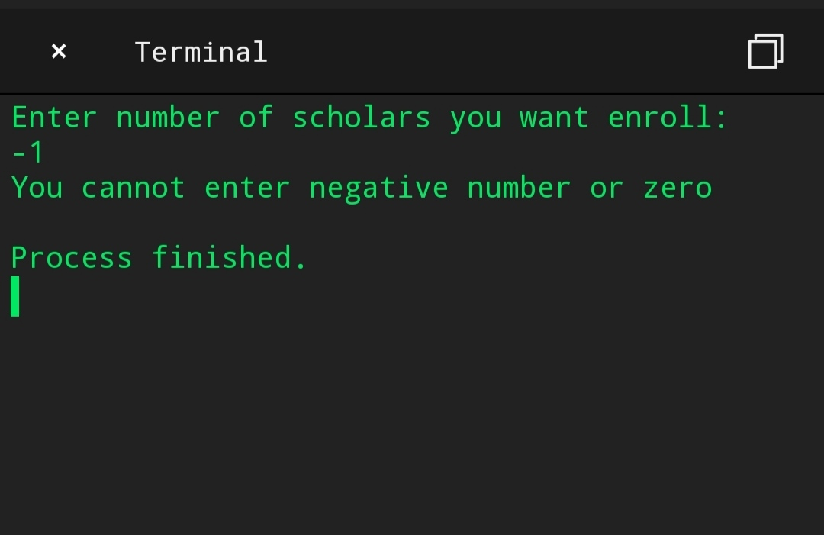

ER Diagram
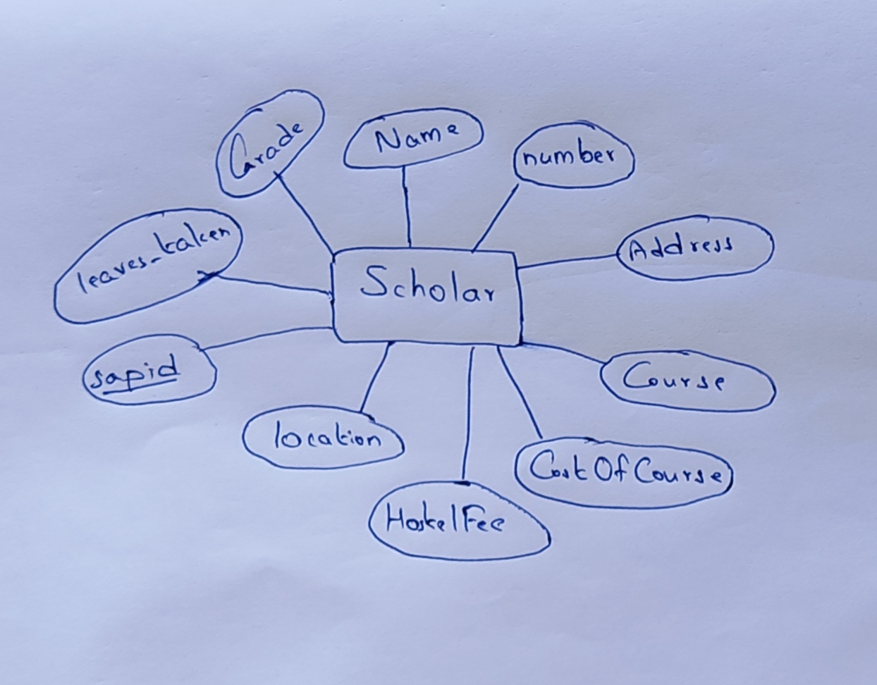

Thank you

